
Part A
51． Directions:
Suppose you are a librarian in your university． Write a notice of about 100 words． providing the newly-enrolled international students with relevant information about the library．
You should write neatly on the ANSWER SHEET．
Do not sign your own name at the end of the notice． Use Li Ming instead．
Do not write the address． (10 points)

Part B
52． Directions:
Write an essay of 160-200 words based on the following pictures． In your essay， you should
1) describe the pictures briefly
2) interpret the meaning ， and
3) give your comments
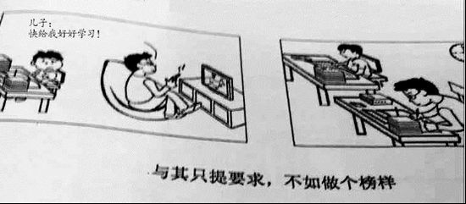

Part A
51. Directions:
You are going to host a club reading session. Write an email of about 100 words recommending a book to the club members.
You should state reasons for your recommendation.
You should write neatly on the ANSWER SHEET.
Do not sign your own name at the end of the letter. Use Li Ming instead.
Do not write the address. (10 points)

Part B
52. Directions:
Write an essay of 160-200 words based on the following drawing. In your essay you should
1) describe the drawing briefly
2) explain its intended meaning, and
3) give your comments
You should write neatly on the ANSWER SHEET. (20 points)
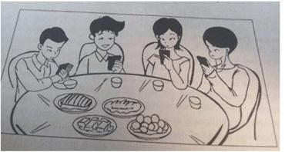

You are to write an email to James Cook, a newly-arrived Australian professor, recommending some tourist attractions in your city. Please give reasons for your recommendation.
You should write neatly on the ANSWER SHEET.
Do not sign your own name at the end of the email. Use “Li Ming” instead.
Do not write the address. (10 points)

52. Directions：
Write an essay of 160-200 words based on the following pictures. In your essay, you should
1)describe the pictures briefly,
2)interpret the meaning , and
3)give your comments.
You should write neatly on the ANSWER SHEET. (20 points )
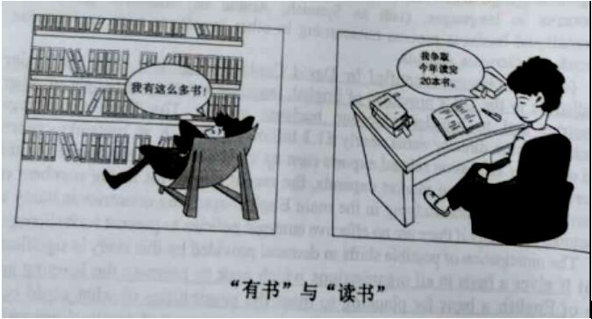

Section III Writing
Part A
51. Directions：
Write an email to all international experts on campus inviting them to attend the graduation ceremony. In your email you should include time, place and other relevant information about the ceremony.
You should write about 100 words neatly on the ANSEWER SHEET
Do not use your own name at the end of the email. Use “Li Ming” instead. (10 points)

Part B
52. Directions：
Write an essay of 160-200 words based on the picture below. In your essay, you should
1)describe the pictures briefly
2)interpret the meaning and
3)give your comments(20 points)
You should write neatly on the ANSWER SHEET. (20 points )
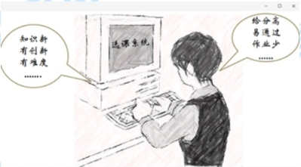

Directions：
Suppose you are working for the “Aiding rural Primary School” project of your university write an email to answer the inquiry from an international student volunteer, specifying the details of the project.
You should write about 100 words neatly on the ANSEWER SHEET
Do not use your own name in the email. Use “Li Ming” instead. (10 points)

Part B
Directions：
Write an essay of 160-200 words based on the picture below. In your essay, you should
- describe the pictures briefly
- interpret the meaning and
- give your comments
You should write neatly on the ANSWER SHEET. (20 points )
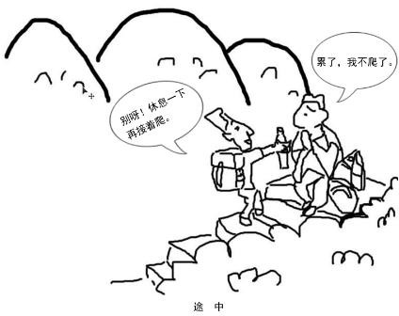

Section IV Writing

Part A
51.Directions:
The Student Union of your university has assigned you to inform the international students an upcoming singing contest. Write a notice in about100 words.
Write your answer on the ANSWER SHEET.
Do not use your name in the notice.

52: Directions:
Write an essay of 160-200 words based on the picture below. In your essay, you should:
1) Describe the picture briefly;
2) Interpret the implied meaning, and
3) Give your comments
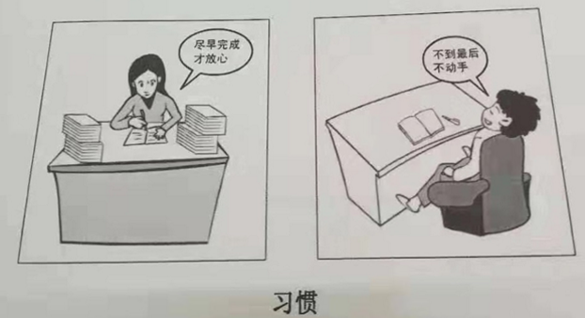

Part A
51. Directions:
Write a letter of about 100 words to the president of your university, suggesting how to improve students’ physical condition.
You should include the details you think necessary.
You should write neatly on the ANSWER SHEET.
Do not sign your own name at the end of the letter. Use “Li Ming” instead.
Do not write the address.(10 points)

Part B
52. Directions:
Write an essay of 160-200 words based on the following drawing. In your essay, you should
1）describe the drawing briefly,
2）interpret its intended meaning, and
3）give your comments.
You should write neatly on the ANSWER SHEET (20 points)
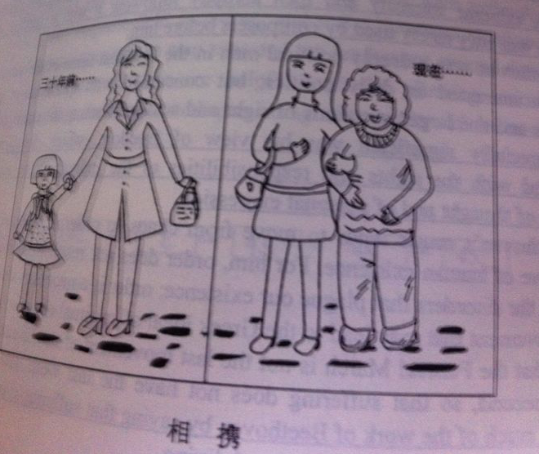

Section IV Writing
Part A
51. Directions:
Write an e-mail of about 100 words to a foreign teacher in your college, inviting him/her to be a judge for the upcoming English speech contest.
You should include the details you think necessary.
You should write neatly on the ANSWER SHEET 2.
Do not sign your own name at the end of the e-mail. Use “Li Ming” instead.
Do not write the address. (10 points)

Part B
52. Directions:
Write an essay of 160-200 words based on the following drawing. In your essay you should
1) describe the drawing briefly
2) explain its intended meaning, and
3) give your comments
You should write neatly on the ANSWER SHEET 2. (20 points)
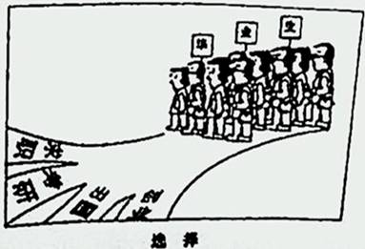

- Directions:

One foreign friend of yours has recently graduated from college and intends to find a job in China. Please write an email to him/her to make some suggestions.
You should write about 100 words on the ANSWER SHEET.

Do not use your own name in the email. Use “ Li Ming” instead. (10 points)

Part B

- Directions:

Write an essay of 160-200 words based on the pictures below. In your essay, you should

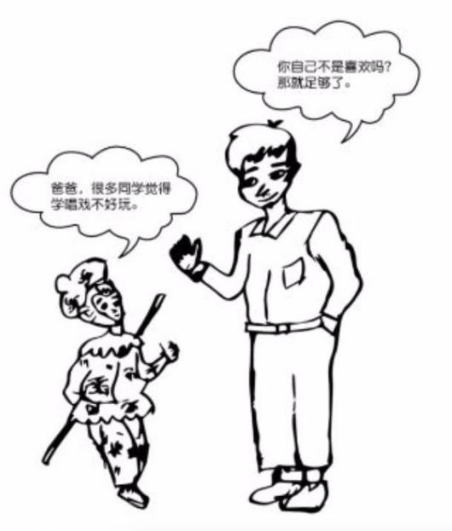
- describe the picture briefly,

- interpret its intended meaning, and

- give your comments.

You should write neatly on the ANSWER SHEET

